Maintain a patient queue using a linked list where

* Patients can be added (registered) at the end.
* Emergency patients should be added at the beginning.
* Support removing discharged patients.

import java.util.\*;

public class Main {

static class Patient {

String name;

Patient next;

public Patient(String name) {

this.name = name;

this.next = null;

}

}

static class PatientQueue {

private Patient head;

public void addPatient(String name) {

Patient newPatient = new Patient(name);

if (head == null) {

head = newPatient;

} else {

Patient temp = head;

while (temp.next != null) {

temp = temp.next;

}

temp.next = newPatient;

}

}

public void addEmergencyPatient(String name) {

Patient newPatient = new Patient(name);

newPatient.next = head;

head = newPatient;

}

public void dischargePatient(String name) {

if (head == null) {

System.out.println("Queue is empty.");

return;

}

if (head.name.equals(name)) {

head = head.next;

System.out.println("Discharged: " + name);

return;

}

Patient prev = head;

Patient curr = head.next;

while (curr != null && !curr.name.equals(name)) {

prev = curr;

curr = curr.next;

}

if (curr == null) {

System.out.println("Patient " + name + " not found.");

} else {

prev.next = curr.next;

System.out.println("Discharged: " + name);

}

}

public void displayQueue() {

if (head == null) {

System.out.println("Queue is empty.");

return;

}

Patient temp = head;

System.out.print("Patient Queue: ");

while (temp != null) {

System.out.print(temp.name + " -> ");

temp = temp.next;

}

System.out.println("null");

}

}

public static void main(String[] args) {

PatientQueue queue = new PatientQueue();

queue.addPatient("John");

queue.addPatient("Emma");

queue.addEmergencyPatient("Drake");

queue.addPatient("Sophia");

queue.addEmergencyPatient("Mia");

System.out.println("Initial Patient Queue:");

queue.displayQueue();

System.out.println("\nDischarging patient: Emma");

queue.dischargePatient("Emma");

System.out.println("\nUpdated Patient Queue:");

queue.displayQueue();

}

}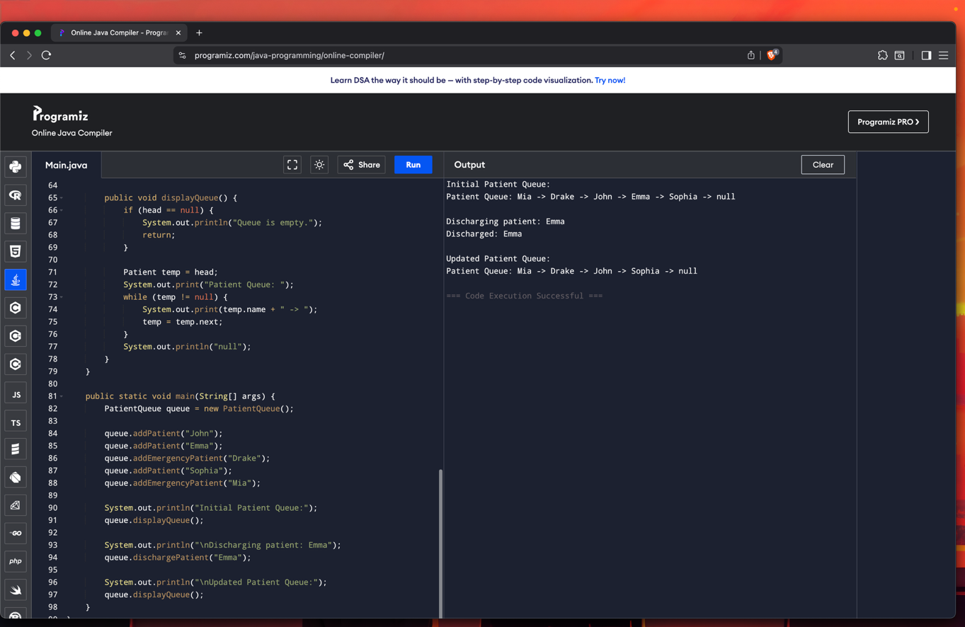

1. Browser History (Using Stack)

Scenario: Simulate a web browser’s back and forward functionality using two stacks. Features:

Visit new page→ Push to `backStack`, clear `forwardStack`.

Go back → Pop from `backStack` and push to `forwardStack`.

Go forward → Pop from `forwardStack` and push to `backStack`.

Use two Stacks

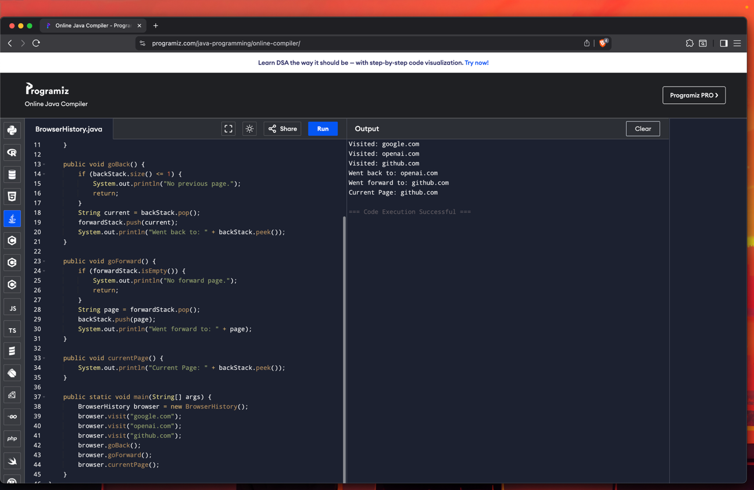

2. Print Queue (Using LinkedList as Queue)

Scenario: Simulate a printer that handles print jobs in FIFO order.

Features:

\* Add new print jobs

\* Process jobs in order

\* View pending jobs

Use LinkedList as Queue

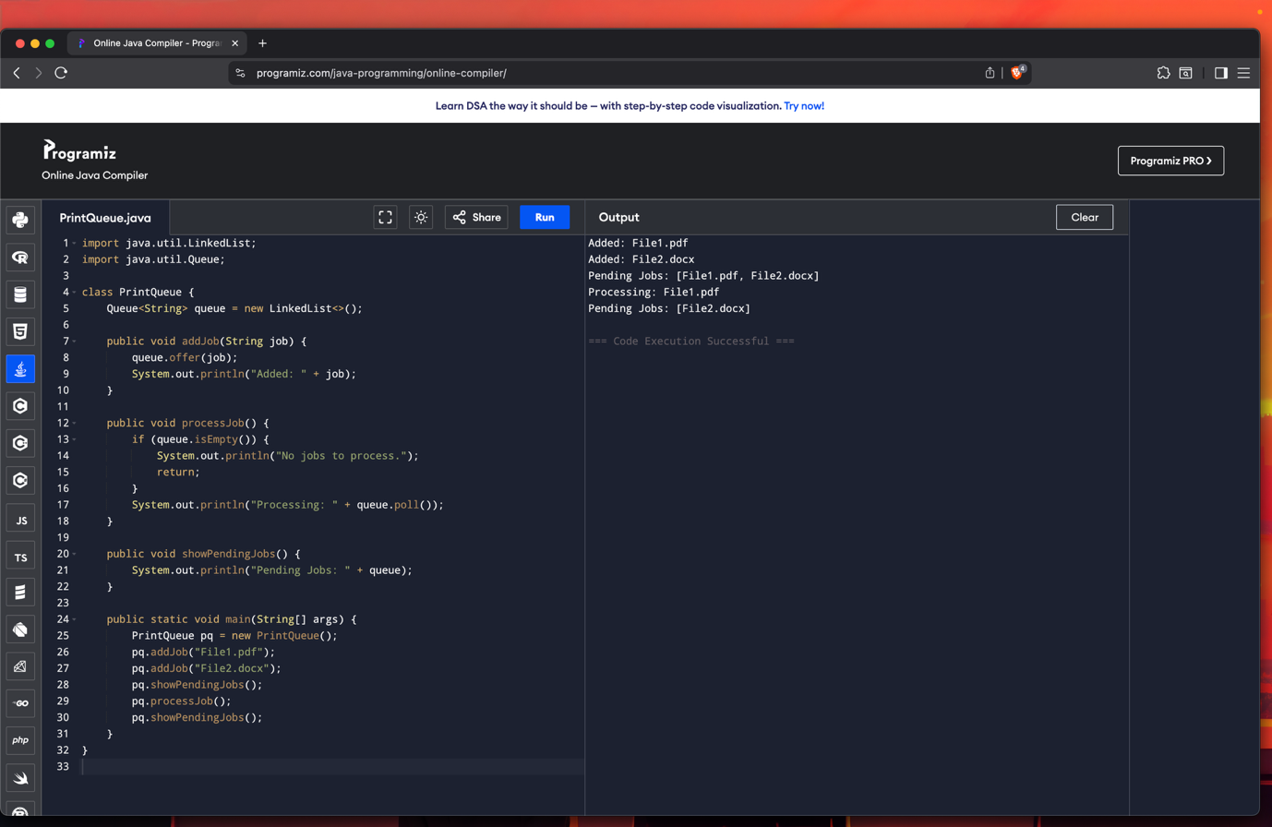

3. Hospital Bed Management (Using LinkedList)

Scenario: Track patients occupying hospital beds.

Features:

\* Assign bed to new patient

\* Discharge patient (remove by name or ID)

\* Display current occupancy

Use LinkedList to represent beds

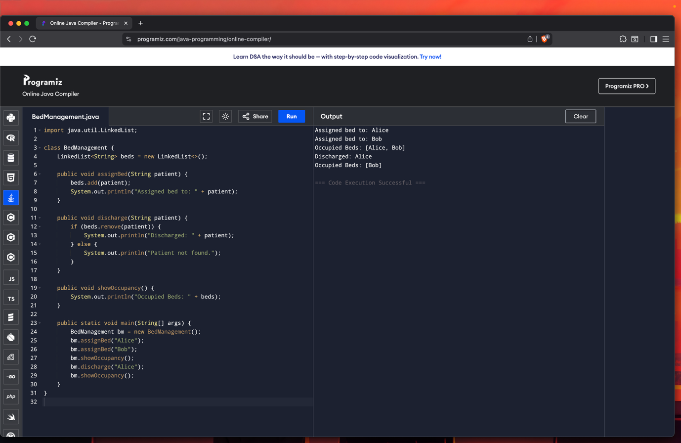

4. Undo-Redo Function (Using Stack)

Scenario: Track document edits with undo and redo.

Features:

\* Perform an action → Push to `undoStack`

\* Undo → Move action to `redoStack`

\* Redo → Move back to `undoStack`

Use two Stacks

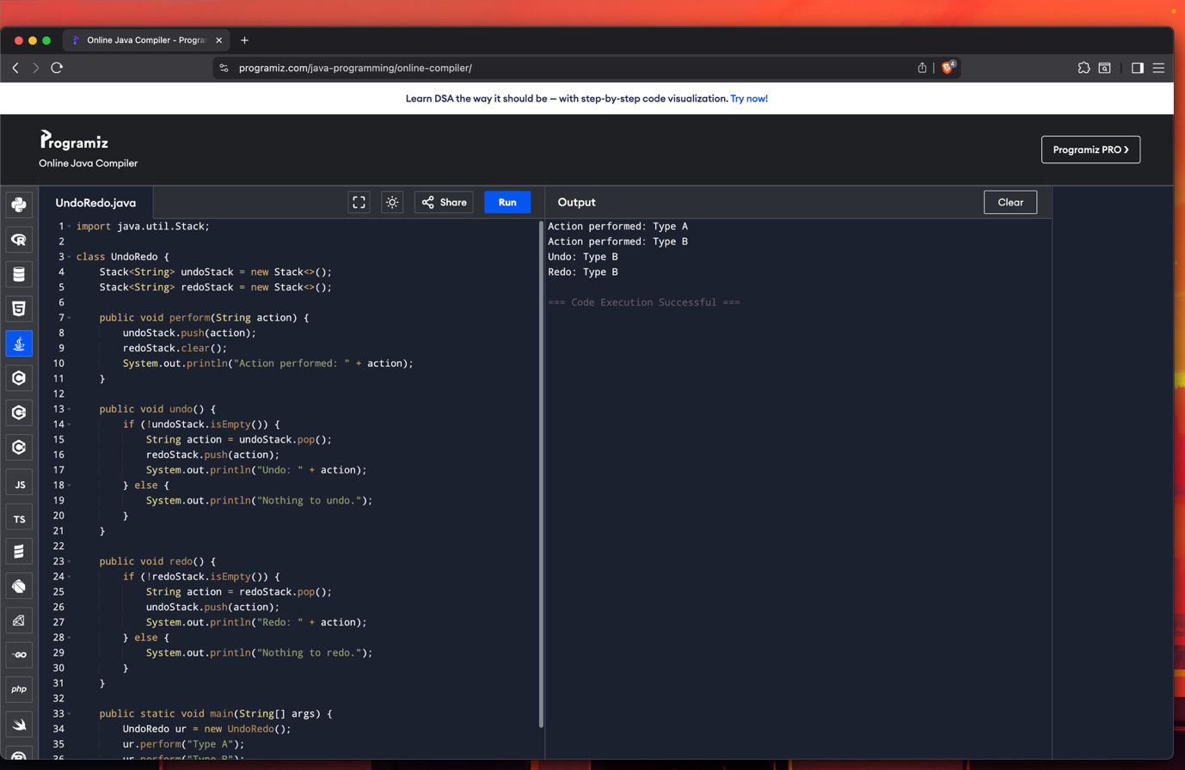

5. Ticket Booking System (Using Queue)\*\*

Scenario: People are queued to book movie/train tickets.

Features:

\* Add person to booking queue

\* Serve next person (dequeue)

\* Cancel ticket (remove specific person)

Use Queue with LinkedList

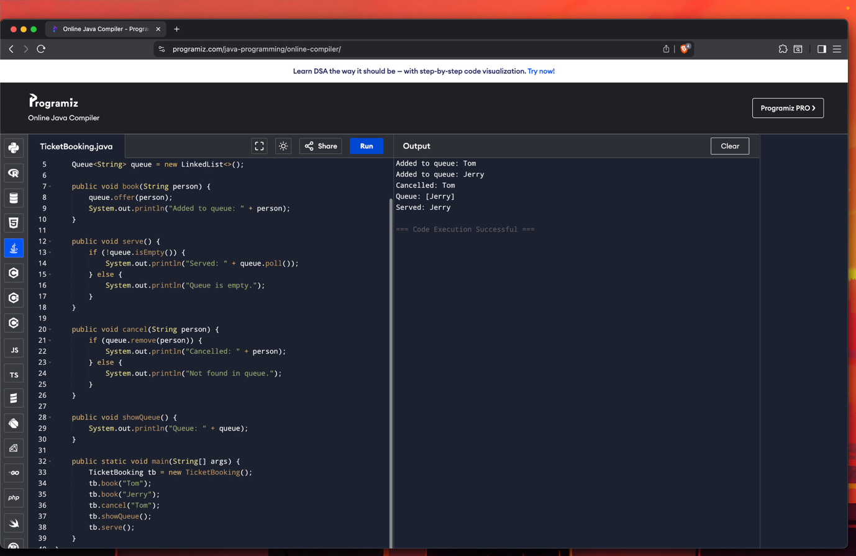

6. Car Wash Service Queue

Scenario: Cars line up at a car wash center.

Features:

\* Add normal cars to the end

\* VIP cars go to the front

\* Remove car after washing

Use LinkedList with front/back insertions

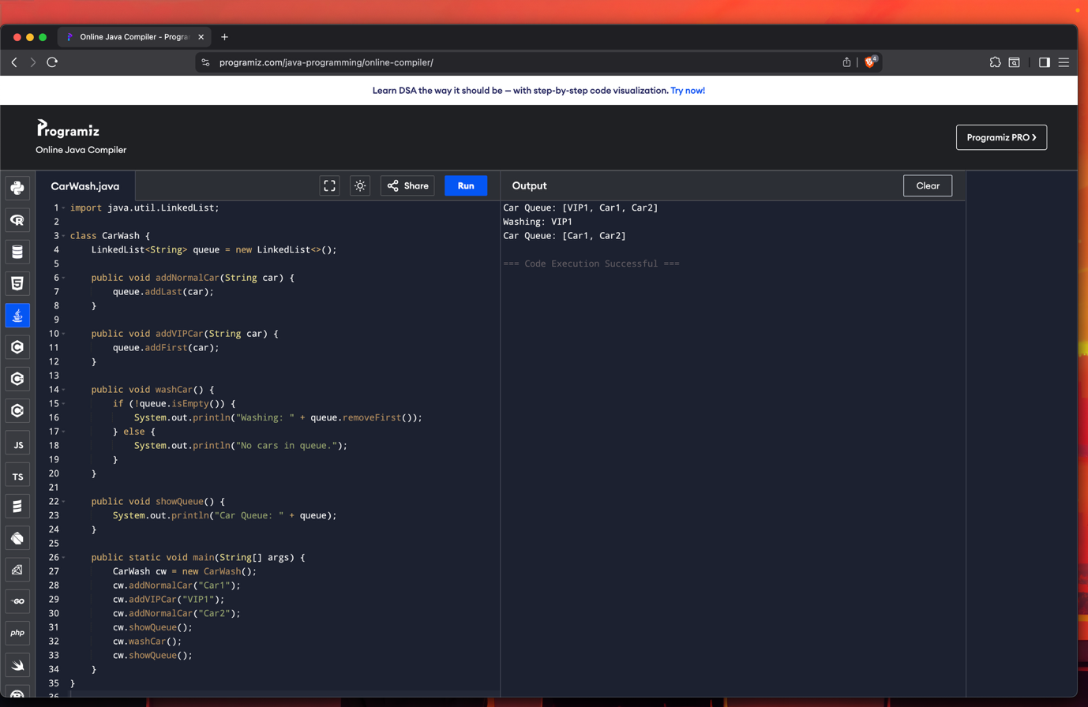

7. Library Book Stack (Using Stack)\*\*

Scenario: Books are stacked in a last-in-first-out order.

Features:

\* Add book (push)

\* Remove book (pop)

\* Peek top book

Use Stack

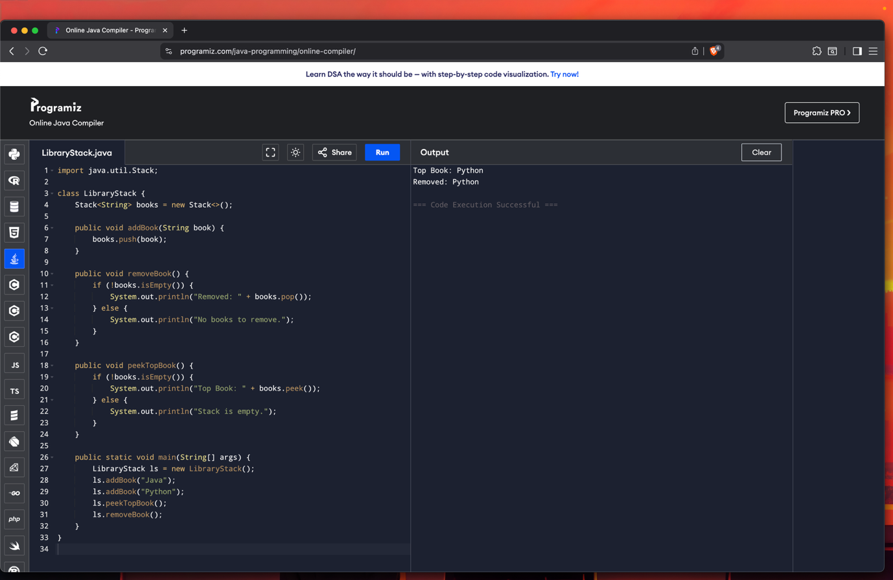

\*8. Expression Evaluator (Infix to Postfix & Evaluate)

Scenario: Create a calculator to evaluate expressions.

Features:

\* Convert infix to postfix

\* Evaluate postfix using stack

Use Stack for operators and operands

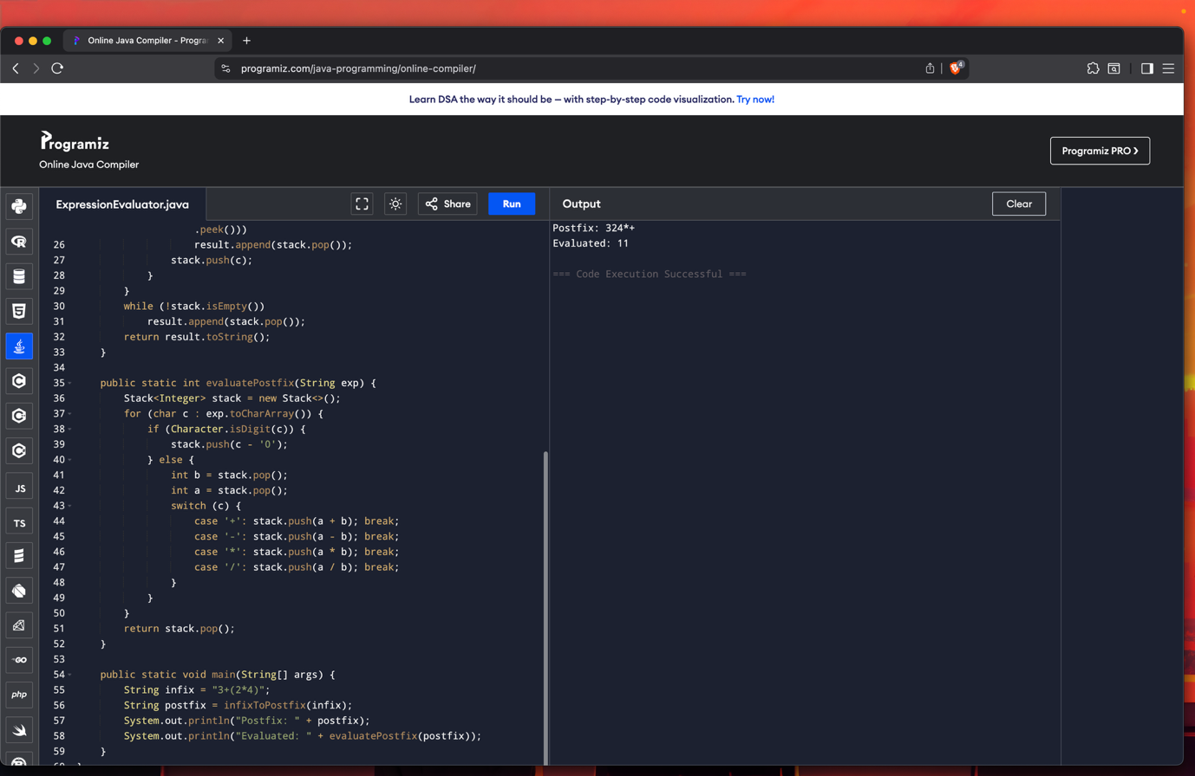

9. Reverse Queue Using Stack\*\*

Scenario: Reverse the order of a customer service queue.

Features:

\* Enqueue customers

\* Reverse using stack

\* Display new order

Use Queue + Stack

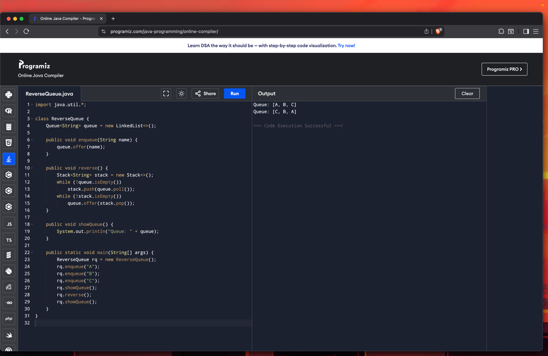

10. Student Admission Queue with Emergency Slot

Scenario: College admission line where VIP quota students are handled first.

Features:

\* Add student normally (end)

\* Add VIP (front)

\* Remove admitted student

Use LinkedList

